**Applying Group Learning to improve prediction performance of classifiers (e.g., SVM and CNN) trained using sparse data**

* **Binary classification (positive vs. negative samples):**

Positive samples (8 ‘digit 2’, 8 ‘digit 3’, 8 ‘digit 4’, 4 ‘digit 1’, 4 ‘digit 7’)

Negative samples (8 ‘digit 2’, 8 ‘digit 3’, 8 ‘digit 4’, 8 ‘digit 1’)

* **Experimental setting:**

Classifiers: linear SVM, CNN

Training data: 20 (10 per class)

Validation data (for SVM): 20 (10 per class)

Test data: 200 (100 per class)

* **Partition data for Group Learning (with different window sizes):**

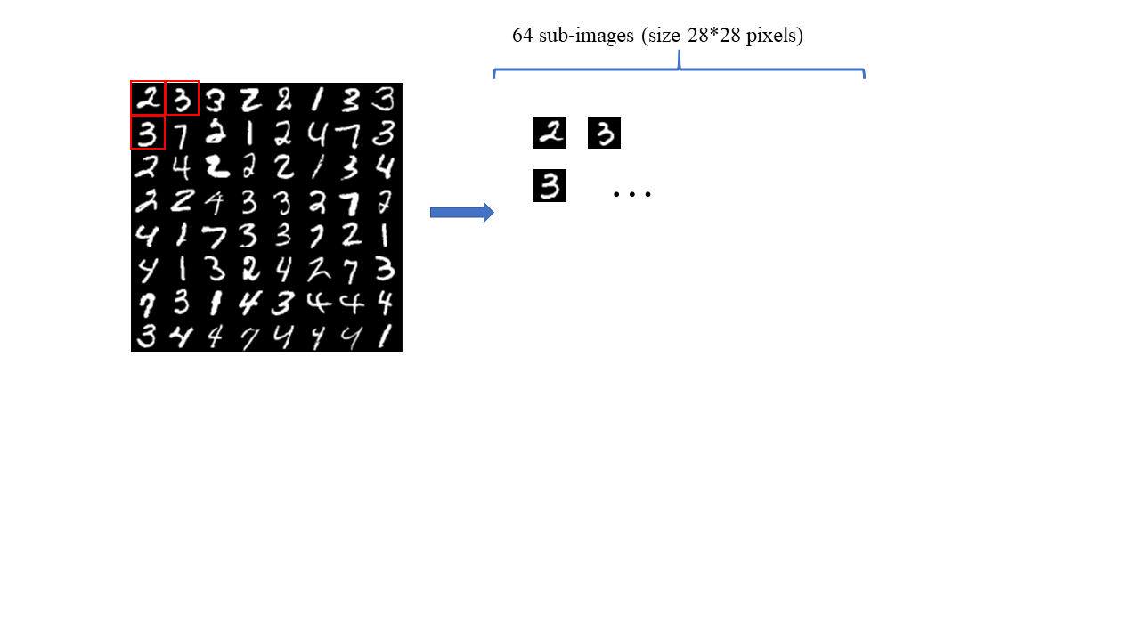

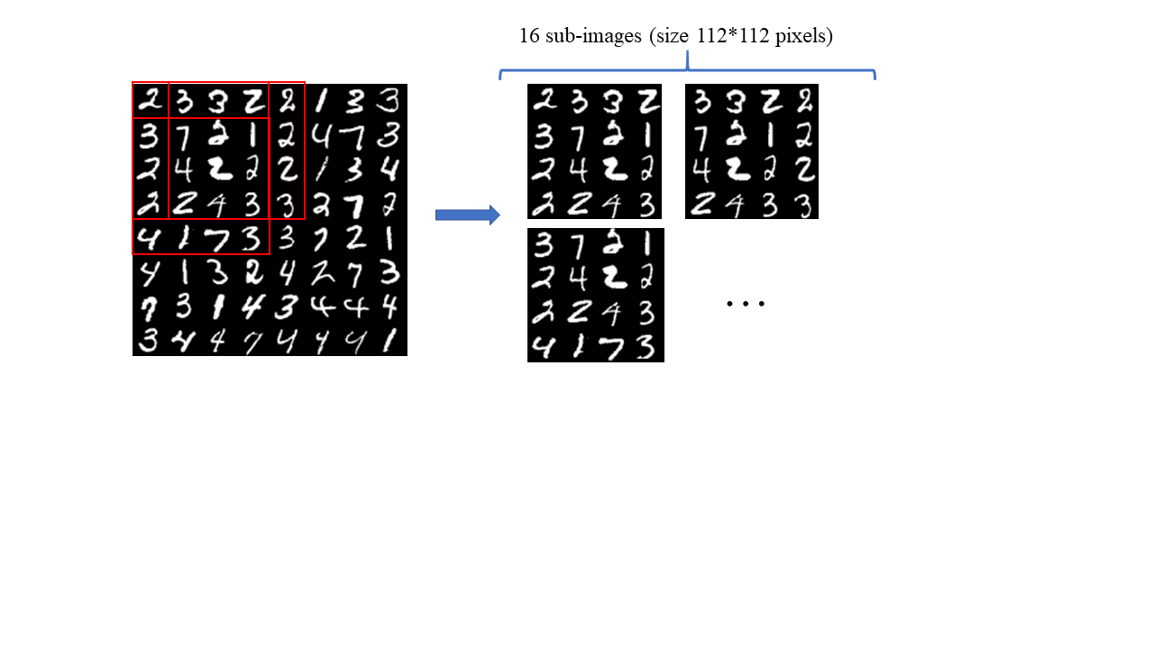

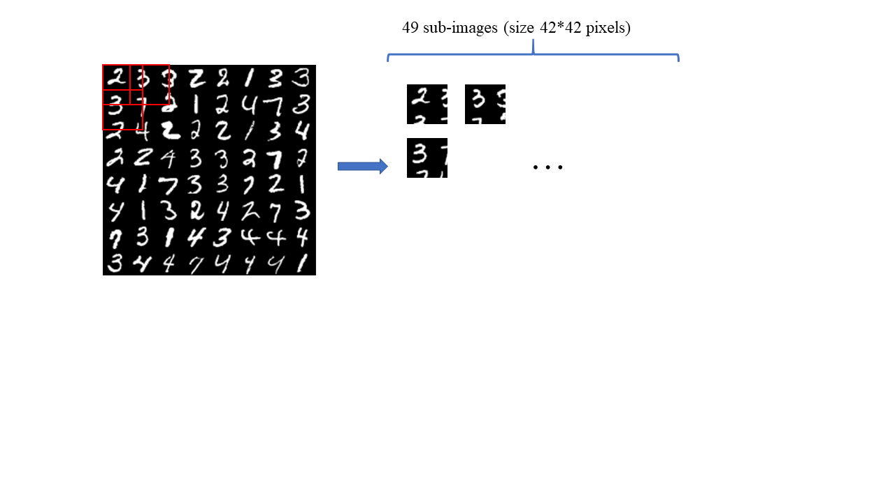

* **Results:**

1. SVM vs. SVM+GL
2. CNN vs. CNN+GL